6th Grade
Math Aligned
Sample Items

Created for Morehouse Parish School System by Dr. Stacey Pullen

6th Grade
Sample Math Items Aligned to CCSS
Table of Contents

CCSS Code | Page # | CCSS Code | Page #
6.RP.A.1 | 3 | 6.EE.B.7 | 42
6.RP.A.2 | 5 | 6.EE.B.8 | 44
6.RP.A.3 | 7 | 6.EE.C.9 | 45
6.RP.A.3a | 9 | 6.G.A.1 | 47
6.RP.A.3b | 10 | 6.G.A.2 | 48
6.RP.A.3c | 11 | 6.G.A.3 | 49
6.RP.A.3d | 12 | 6.G.A.4 | 50
6.NS.A.1 | 13 | 6.SP.A.1 | 52
6.NS.B.2 | 15 | 6.SP.A.2 | 53
6.NS.B.3 | 16 | 6.SP.A.3 | 55
6.NS.B.4 | 17 | 6.SP.B.4 | 56
6.NS.C.5 | 18 | 6.SP.B.5 | 58
6.NS.C.6 | 20 | 6.SP.B.5a | 60
6.NS.C.6a | 21 | 6.SP.B.5b | 61
6.NS.C.6b | 23 | 6.SP.B.5c | 62
6.NS.C.6c | 24 | 6.SP.B.5d | 64
6.NS.C.7 | 25 | Answer Key | 65
6.NS.C.7a | 26 | Rubrics | 67
6.NS.C.7b | 27 | Origination of Items | 74
6.NS.C.7c | 28
6.NS.C.7d | 30
6.NS.C.8 | 31
6.EE.A.1 | 32
6.EE.A.2 | 33
6.EE.A.2a | 34
6.EE.A.2b | 35
6.EE.A.2c | 36
6.EE.A.3 | 38
6.EE.A.4 | 39
6.EE.B.5 | 40
6.EE.B.6 | 41
6th Grade
Sample Math Items Aligned to CCSS
6. RP.A.1
Understand the concept of a ratio and use ratio language to describe a ratio relationship between two quantities. For example, "The ratio of wings to beaks in the bird house at the zoo was 2:1, because for every 2 wings there was 1 beak." "For every vote candidate A received, candidate C received nearly three votes." (Conceptual Understanding)

What test questions look like:
Sample 1:
The table below shows the number of pets, by type, the sixth grade students have at Middleton Elementary School.

Pets
Pet Type | Number of Pets
dog | 54
cat | 42
fish | 14
hamster | 8

What is the ratio of cats as pets to fish as pets?
- 1 to 3
- 3 to 1
- 9 to 7
- 7 to 9

Sample 2:
Desean counted the e-mails he sent and received last week. The ratio of e-mails he sent to e-mails he received is 2:3. Which statement about the e-mails Desean sent and received last week must be true?
  - Desean sent and received a total of 5 e-mails last week.

  - Desean sent more e-mails than he received last week.
  - A total of of the e-mails Desean counted from last week were e-mails he sent.
  - For every 3 e-mails Desean received last week, he sent 2 e-mails.

6. RP.A.2
Understand the concept of a unit rate a/b associated with a ratio a:b with b ≠ 0, and use rate language in the context of a ratio relationship. For example, "This recipe has a ratio of 3 cups of flour to 4 cups of sugar, so there is 3/4 cup of flour for each cup of sugar." "We paid $75 for 15 hamburgers, which is a rate of $5 per hamburger." (Conceptual Understanding)

What test questions look like:
Sample 1:
Mr. Zenon makes baby food. The baby food is a mixture of apples and pears. The ratio of cups of apples to cups of pears in the baby food is 5:2.
Which statements about the baby food that Mr. Zenon makes are true?
Select all the correct statements.
- The total volume of the baby food is always 7 cups.

- The total volume of the baby food, in cups, is always a multiple of 7.

- The baby food always has exactly 3 more cups of apples than cups of pears.

- For every cup of pears in the baby food, Mr. Zenon includes 2 cups of apples.

- For every cup of apples in the baby food, Mr. Zenon includes cup of pears.

Sample 2:
There are 18 gallons of juice and 30 gallons of milk at a restaurant. Which statement correctly describes the unit rate of juice to milk at the restaurant?
- There are 0.6 gallon of juice for every 1 gallon of milk.

- There are 1.8 gallons of juice for every 1 gallon of milk.

- There is 1 gallon of juice for every 12 gallons of milk.

- There is 1 gallon of juice for every 3 gallons of milk.

6. RP.A.3
Use ratio and rate reasoning to solve real-world and mathematical problems, e.g., by reasoning about tables of equivalent ratios, tape diagrams, double number line diagrams, or equations. (Conceptual Understanding & Application)

What test questions look like:
Sample 1:
Mr. Patterson wants to buy the brand of socks that gives him the best deal. This table shows the prices for different packages of socks.

Brand | Number of  Pairs of Socks | Price
A-One Socks | 1 | $1.69
Hop-Around Socks | 2 | $3.99
Super Socks | 4 | $6.49
Lots of Socks | 5 | $8.99

Which brand should Mr. Patterson buy?

- A-One Socks
- Hop-Around Socks
- Super Socks
- Lots of Socks

Sample 2:
Chloe places one red ball on one side of this scale. She places two yellow triangles on the other side. The scale is balanced.
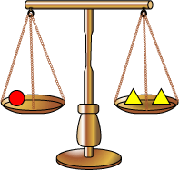
Which picture shows another way that the scale will balance?

- 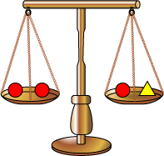
- 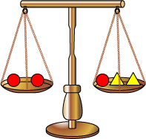
- 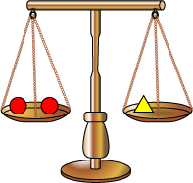
- 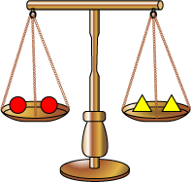

6. RP.A.3a
Make tables of equivalent ratios relating quantities with whole-number measurements, find missing values in the tables, and plot the pairs of values on the coordinate plane. Use tables to compare ratios. (Conceptual Understanding & Procedural Skill and Fluency & Application)

What test questions look like:
Sample 1:
The ratio of the sales tax to the amount of purchase is a fixed number in Town Q. The table shows the sales tax for a purchase of $1,200. Town Q Tax
Purchase | Sales Tax
$1,200 | $72
$2,500 | ?
? | $108

Part A
What is the sales tax for a purchase of $2,500?
- $18.06
- $34.72
- $144.00
- $150.00

Part B
What is the cost of an item with a sales tax of $108?
- $432
- $648
- $1,092
- $1,800

6. RP.A.3b
Solve unit rate problems including those involving unit pricing and constant speed. For example, if it took 7 hours to mow 4 lawns, then at that rate, how many lawns could be mowed in 35 hours? At what rate were lawns being mowed? (Application)

What test questions look like:
Sample 1:
David is conducting a survey by going door-to-door. He visited 60 homes in 2.5 hours. At that rate, how much time, in hours, will it take David to visit 90 homes?
Enter your answer in the box.

6. RP.A.3c
Find a percent of a quantity as a rate per 100 (e.g., 30% of a quantity means 30/100 times the quantity); solve problems involving finding the whole, given a part and the percent. (Conceptual Understanding & Application)

What test questions look like:
Sample 1:

Based on information from previous years, 40% of the fans at each of a baseball team’s games are female. At one of the team’s games this year, there were 480 female fans. Based on the information from previous years, what was the total number of fans at that game?
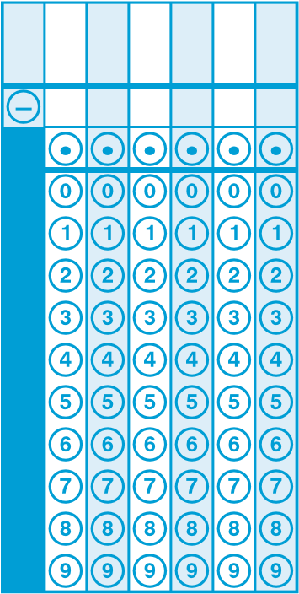
Enter your answer in the box.

6. RP.A.3d
Use ratio reasoning to convert measurement units; manipulate and transform units appropriately when multiplying or dividing quantities. (Conceptual Understanding & Procedural Skill and Fluency)

What test questions look like:
Sample 1:
Gary is installing square floor tiles on a floor with an area of 160 square feet. Each tile covers 16 square inches. How many tiles does he need to cover the floor?

- 10
- 120
- 214
- 1,440

Sample 2:
Marilyn sees a drawing of a footprint that was supposedly made by the creature “Bigfoot.”
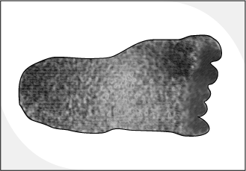
The footprint covers an area of 3 square feet. How many square inches does the footprint cover?

- 9 square inches
- 36 square inches
- 108 square inches
- 432 square inches
6. NS.A.1
Interpret and compute quotients of fractions, and solve word problems involving division of fractions by fractions, e.g., by using visual fraction models and equations to represent the problem. For example, create a story context for (2/3) ÷ (3/4) and use a visual fraction model to show the quotient; use the relationship between multiplication and division to explain that (2/3) ÷ (3/4) = 8/9 because 3/4 of 8/9 is 2/3. (In general, (a/b) ÷ (c/d) = ad/bc.) How much chocolate will each person get if 3 people share 1/2 lb of chocolate equally? How many 3/4-cup servings are in 2/3 of a cup of yogurt? How wide is a rectangular strip of land with length 3/4 mi and area 1/2 square mi?. (Conceptual Understanding & Procedural Skill and Fluency & Application)

What test questions look like:
Sample 1:
Mr. Polandski is adding food coloring to water to create his own paint colors. He has 5 cups of water. To create a color, he needs cup of water. How many paint colors, in all, can Mr. Polandski create if he uses all the cups of water he has?
Enter your answer in the box.
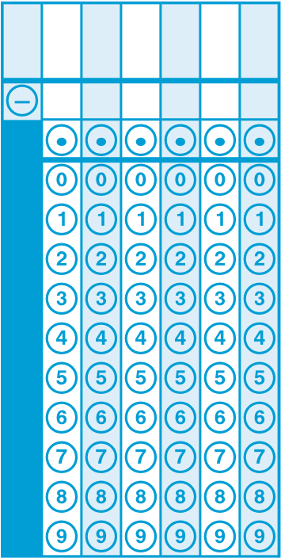
Sample 2:
One size of cardboard can be purchased in sheets that are 3/16 inch thick. The sheets
of cardboard are stacked on top of each other in packages. The height of each stack is 2 ¼ inches.
inches
1
2
3
4
  - Use the model of a ruler to determine the number of sheets of cardboard in a stack.
  - Explain how you used the model to find your answer.
  - Write an expression that can be used to determine the number of sheets of cardboard in a stack.
  - Explain how your expression relates to the model.
Enter your answer, your expression, and your explanations in the box provided.

6. NS.B.2
Fluently divide multi-digit numbers using the standard algorithm. (Procedural Skill and Fluency)

What test questions look like:
Sample 1:
What is 437 ÷ 19?
- 13
- 19
- 22
- 23
Sample 2:
What is the value of 351 ÷ 26?
- 12 3/20

- 13 5/13

- 13 ½

- 14 7/26

6. NS.B.3
Fluently add, subtract, multiply, and divide multi-digit decimals using the standard algorithm for each operation. (Procedural Skill and Fluency)

What test questions look like:
Sample 1:

Megan spent $9.85 on ingredients and made one pan of cereal bars. The pan has a length of 24 inches and a width of 16 inches.
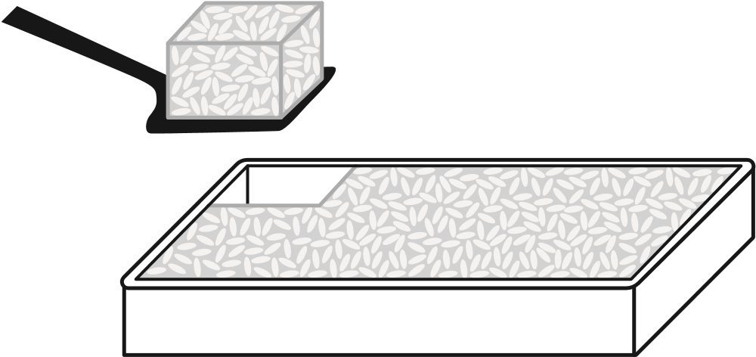
Megan needs to cut individual cereal bars from the pan. Each cereal bar should be the same size and shape and should represent a reasonable serving.
Estimate an appropriate length and width for each cereal bar and explain your assumptions.
Based on your estimate, determine the amount each cereal bar will cost Megan to make. Show your work or explain your reasoning.
Enter your answers and your work or explanations in the box provided.

6. NS.B.4
Find the greatest common factor of two whole numbers less than or equal to 100 and the least common multiple of two whole numbers less than or equal to 12. Use the distributive property to express a sum of two whole numbers 1-100 with a common factor as a multiple of a sum of two whole numbers with no common factor. For example, express 36 + 8 as 4 (9 + 2). (Conceptual Understanding & Procedural Skill and Fluency)

What test questions look like:
Sample 1:
What is the greatest common factor of 78 and 96?
A. 2
B. 6
C. 8
D. 12

6. NS.C.5
Understand that positive and negative numbers are used together to describe quantities having opposite directions or values (e.g., temperature above/below zero, elevation above/below sea level, credits/debits, positive/negative electric charge); use positive and negative numbers to represent quantities in real-world contexts, explaining the meaning of 0 in each situation. (Conceptual Understanding & Application)

What test questions look like:
Sample 1:
William and Jason are playing a game. William started at zero and moved in the negative direction 9 spaces, which he modeled with the number –9. James also started at zero and moved in the opposite direction 9 spaces.
Which number models Jason’s position in the game?
Enter your answer in the box.
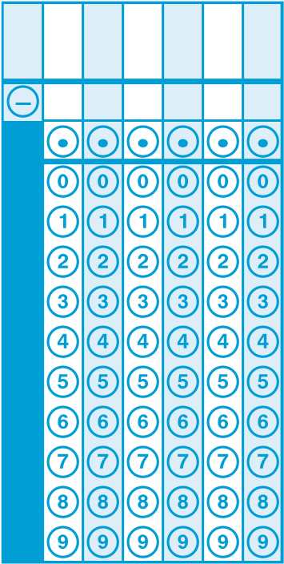

Sample 2:
Holly records the temperature, in degrees Fahrenheit, for two different cities. In one of the cities, the temperature is 15 degrees above zero. Holly records this as 15. In the other city, the temperature is 15 degrees below zero. Which value represents the temperature Holly records?

- -30

- -15

- 15

- 30

6. NS.C.6
Understand a rational number as a point on the number line. Extend number line diagrams and coordinate axes familiar from previous grades to represent points on the line and in the plane with negative number coordinates. (Conceptual Understanding)
What test questions look like:
Sample 1:
Which number line has the values , , 0.25, and 0.75 placed in the correct locations?

Sample 2:
Which numbers best represent point A on the number line?
I. -2.2
II. -2.3
III. -2.4
IV. -215
V. -225

- I
- II
- I and V
- III and V

6. NS.C.6a
Recognize opposite signs of numbers as indicating locations on opposite sides of 0 on the number line; recognize that the opposite of the opposite of a number is the number itself, e.g., -(-3) = 3, and that 0 is its own opposite. (Conceptual Understanding)

What test questions look like:
Sample 1:
Points P, Q, and R are shown on the number line.

P Q R

−1 −0.8 −0.6 −0.4 −0.2 0 0.2 0.4 0.6 0.8 1

Part A
Find the distances between points P and Q and between points R and Q. Show your work or explain your answers. Refer to the number line in your explanation.
Enter your answers and your work or explanation in the box provided.

Part B

Point S is a different point on the number line. Point S and point R are the same distance from point Q. Explain how to determine the location of point S on the number line.
Enter your explanation in the box provided
6. NS.C.6b
Understand signs of numbers in ordered pairs as indicating locations in quadrants of the coordinate plane; recognize that when two ordered pairs differ only by signs, the locations of the points are related by reflections across one or both axes. (Conceptual Understanding)

What test questions look like:
Sample 1:
Jolie draws a map of her neighborhood on a coordinate plane. She draws her house at a point in Quadrant II of the coordinate plane.
0
10
8
6
4
2
2
6
10
8
x
y
–
2
–
4
–
6
–
8
–
10
–
6
–
4
4
–
10
–
8
–
2
Quadrant II
Select all the points that could represent the location of Jolie’s house.
- (0, 5)

- (1, –4)

- (–2, 0)

- (–4, 7)

- (–3, –1)

- (–1, 9)
6. NS.C.6c
Find and position integers and other rational numbers on a horizontal or vertical number line diagram; find and position pairs of integers and other rational numbers on a coordinate plane. (Conceptual Understanding)

What test questions look like:
Sample 1:
This number line shows four points.
A B C D

−4 −3 −2 −1 0 1 2 3 4
Which point is located at ?
- point A

- point B

- point C

- point D

6. NS.C.7
Understand ordering and absolute value of rational numbers. (Conceptual Understanding)

What test questions look like:
Sample 1:
Which comparison is false?

- .4 < 5
- . =
- .-3 < -4
- .0.32 = 0.320
Sample 2:
Select all of the inequalities that are true.
I. -3 > -9
II. 11 < -15
III. 25 > - 40
IV. 1 > -21
V. - 8 > - 6

- II, IV
- I, V
- II, III, IV
- I, III, IV

6. NS.C.7a
Interpret statements of inequality as statements about the relative position of two numbers on a number line diagram. For example, interpret -3 > -7 as a statement that -3 is located to the right of -7 on a number line oriented from left to right. (Conceptual Understanding)

What test questions look like:
Sample 1:
These five rational numbers are plotted on a horizontal number line.
, , 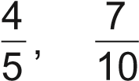,
Which statement about the locations of the rational numbers on the number line is true?
- is farthest to the left, and is farthest to the right.

- is farthest to the left, and is farthest to the right.

- is farthest to the left, and is farthest to the right.

- is farthest to the left, and 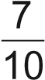 is farthest to the right.

6. NS.C.7b
Write, interpret, and explain statements of order for rational numbers in real-world contexts. For example, write -3 ºC > -7 ºC to express the fact that -3 ºC is warmer than -7 ºC. (Application)

What test questions look like:
Sample 1:
Kyle is thinking of a number that is greater than –6 and less than –6. Which number could be Kyle’s number?
- –6.7
- –6.6
- –6.5
- –6.4

6. NS.C.7c
Understand the absolute value of a rational number as its distance from 0 on the number line; interpret absolute value as magnitude for a positive or negative quantity in a real-world situation. For example, for an account balance of -30 dollars, write |-30| = 30 to describe the size of the debt in dollars. (Conceptual Understanding)

What test questions look like:
Sample 1:

Points P, Q, and R are shown on the number line.
P Q R

−1 −0.8 −0.6 −0.4 −0.2 0 0.2 0.4 0.6 0.8 1

Part A
Find the distances between points P and Q and between points R and Q. Show your work or explain your answers. Refer to the number line in your explanation.
Enter your answers and your work or explanation in the box provided.

Part B
Point S is a different point on the number line. Point S and point R are the same distance from point Q. Explain how to determine the location of point S on the number line.
Enter your explanation in the box provided

6. NS.C.7d
Distinguish comparisons of absolute value from statements about order. For example, recognize that an account balance less than -30 dollars represents a debt greater than 30 dollars. (Conceptual Understanding)

What test questions look like:
Sample 1:
NONE Available

6. NS.C.8
Solve real-world and mathematical problems by graphing points in all four quadrants of the coordinate plane. Include use of coordinates and absolute value to find distances between points with the same first coordinate or the same second coordinate. (Procedural Skill and Fluency & Application)

What test questions look like:
Sample 1:
Ralph plotted the points (–4, 3) and (–4, –3) on a coordinate grid. What is the distance, in units, between the points Ralph plotted?
Enter your answer in the box.
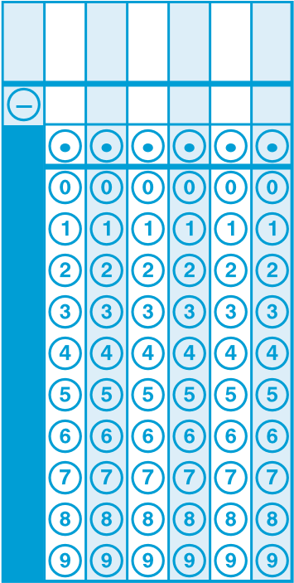

6. EE.A.1
Write and evaluate numerical expressions involving whole-number exponents. (Conceptual Understanding & Procedural Skill and Fluency)

What test questions look like:
Sample 1:

Phil can pack 34 boxes into the back of a moving truck. Each box is 2 feet long, 2 feet wide, and 3 feet tall. Which expression could be used to find the total volume, in cubic feet, of all the boxes Phil can pack into the back of a moving truck?
  - 34 + 2² + 3
  - 34 + 2² × 3
  - 34 × 2² + 3
  - 34 × 2² × 3

6. EE.A.2
Write, read, and evaluate expressions in which letters stand for numbers. (Conceptual Understanding & Procedural Skill and Fluency)
What test questions look like:
Sample 1:
Angela determines that this is the formula for a number pattern.
3(n – 4)
She thinks the 10th term in the pattern is 26. Is Angela correct?
- Yes, the 10th term is 26.
- No, the 10th term is 6.
- No, the 10th term is 18.
- There is not enough information to solve this problem.
Sample 2:
Ms. Stout grows tomatoes in her garden. She uses the expression below to estimate how many tomatoes will grow after n weeks.
12 + 2n
Based on this expression, how many tomatoes will there be after 8 weeks?
Write your answer as a whole number only. Do not add any words, symbols, or punctuation to your answer.

6. EE.A.2a
Write expressions that record operations with numbers and with letters standing for numbers. For example, express the calculation "Subtract y from 5" as 5 - y. (Conceptual Understanding)

What test questions look like:
Sample 1:
The students in a club are selling flowerpots to raise money. Each flowerpot sells for $15.
Part A
Write an expression that represents the total amount of money, in dollars, the students raise from selling x flowerpots.
Enter your expression in the box provided. Enter only your expression

Part B
The goal of the students in the club was to raise $500. They sold 43 flowerpots. By what amount did the students exceed their goal of raising $500? Show or explain all your work.
Enter your answer and your work or explanation in the box provided.

6. EE.A.2b
Identify parts of an expression using mathematical terms (sum, term, product, factor, quotient, coefficient); view one or more parts of an expression as a single entity. For example, describe the expression 2 (8 + 7) as a product of two factors; view (8 + 7) as both a single entity and a sum of two terms. (Conceptual Understanding)

What test questions look like:
Sample 1:
NONE Available

6. EE.A.2c
Evaluate expressions at specific values of their variables. Include expressions that arise from formulas used in real-world problems. Perform arithmetic operations, including those involving whole-number exponents, in the conventional order when there are no parentheses to specify a particular order (Order of Operations). For example, use the formulas V = s³ and A = 6 s² to find the volume and surface area of a cube with sides of length s = 1/2. (Procedural Skill and Fluency & Application)

What test questions look like:
Sample 1:
The formula for converting temperatures from degrees Celsius, C, to degrees Fahrenheit, F, is shown below.
C + 32 = F
What is the temperature in degrees Fahrenheit when the temperature is 25°C?
Enter your answer in the box.

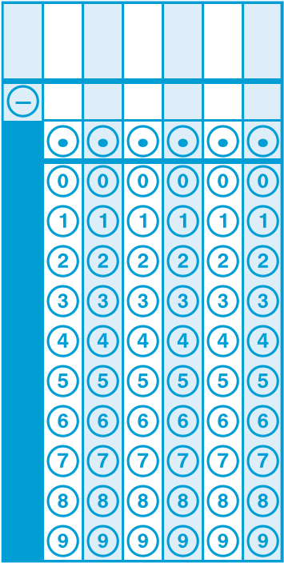

Sample 2:
What is the value of a² + 3b ÷ c – 2d, when a = 3, b = 8, c = 2, and d = 5?
Enter your answer in the box.
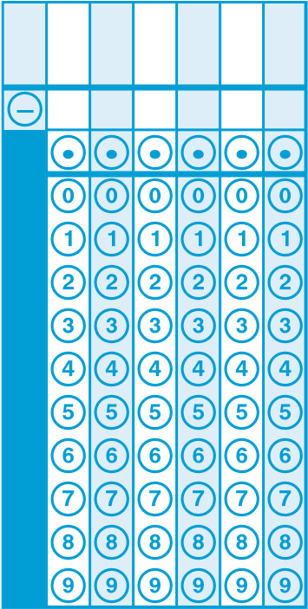
6. EE.A.3
Apply the properties of operations to generate equivalent expressions. For example, apply the distributive property to the expression 3 (2 + x) to produce the equivalent expression 6 + 3x; apply the distributive property to the expression 24x + 18y to produce the equivalent expression 6 (4x + 3y); apply properties of operations to y + y + y to produce the equivalent expression 3y. (Conceptual Understanding)
What test questions look like:
Sample 1:
Brianna’s teacher asks her which of these three expressions are equivalent to each other.
Expression A: 9x – 3x – 4
Expression B: 12x – 4
Expression C: 5x + x – 4
Brianna says that all three expressions are equivalent because the value of each one is4 when x = 0.
Brianna’s thinking is incorrect.
Identify the error in Brianna’s thinking. Determine which of the three expressions are equivalent. Explain or show your process in determining which expressions are equivalent.
Enter your answer and your explanation or process in the box provided.

6. EE.A.4
Identify when two expressions are equivalent (i.e., when the two expressions name the same number regardless of which value is substituted into them). For example, the expressions y + y + y and 3y are equivalent because they name the same number regardless of which number y stands for. (Conceptual Understanding)

What test questions look like:
Sample 1:
The number of pens that Mason has can be described by the expression 2n + 9 where n is the number of pens in an unopened package of pens.
Select all the expressions that could also be used to represent the number of pens that Mason has.
  - 11n
  - 2(n + )
  - 2(n + 8) + 1
  - n + n + 9 + 9
  - (0.5)(4n) + (0.5)(18)
Sample 2:

Select each expression that is equivalent to 3(n + 6).
Select all that apply.
- 3n + 6
- 3n + 18
- 2n + 2 + n + 4
- 2(n + 6) + (n + 6)
- 2(n + 6) + n

6. EE.B.5
Understand solving an equation or inequality as a process of answering a question: which values from a specified set, if any, make the equation or inequality true? Use substitution to determine whether a given number in a specified set makes an equation or inequality true. (Conceptual Understanding & Procedural Skill and Fluency)

What test questions look like:
Sample 1:

The variable x represents a value in the set {4, 6, 7, 8}. Which value of x makes 2(x – 4) + 3 = 7 a true statement?
  - 4

  - 6

  - 7

  - 8

6. EE.B.6
Use variables to represent numbers and write expressions when solving a real-world or mathematical problem; understand that a variable can represent an unknown number, or, depending on the purpose at hand, any number in a specified set. (Conceptual Understanding & Application)

What test questions look like:
Sample 1:
Ali sells her artwork at a local fair. She sells each of her paintings for $12 and each of her sculptures for $20.
Which expression could be used to model the cost of purchasing p paintings and s sculptures.
- 32ps

- 32 + p + s

- 20p + 12s

- 12p + 20s

6. EE.B.7
Solve real-world and mathematical problems by writing and solving equations of the form x + p = q and px = q for cases in which p, q and x are all nonnegative rational numbers. (Procedural Skill and Fluency & Application)
What test questions look like:
Sample 1:
A library charges $0.08 for each page printed from one of its computers. Gareth spent $2.32 to print out several magazine articles. The equation below can be used to determine the total number of pages, p, that Gareth printed.
0.08p = 2.32
What was the total number of pages that Gareth printed?
Enter your answer in the box.
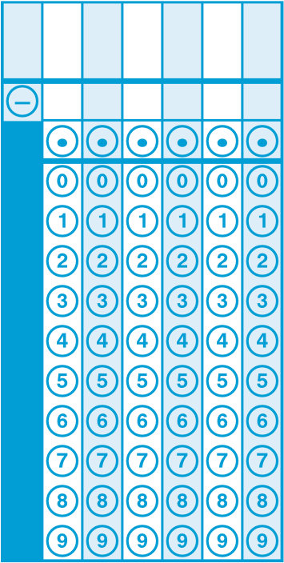

Sample 2:
. Greg bought 4 notebooks for $6.40.

Part A
Which equation can be used to determine the price, p, in dollars, of 1 notebook?
p
- = 6.40
4
p
- = 4
6.40
- 4p = 6.40
- 6.40p = 4

Part B
What is the price, in dollars, of 1 notebook?
Enter your answer in the box.
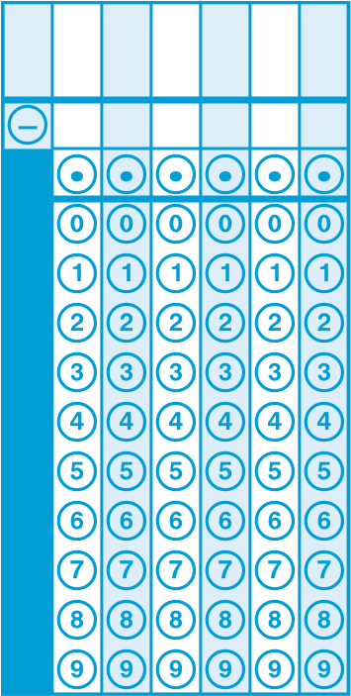

6. EE.B.8
Write an inequality of the form x > c or x < c to represent a constraint or condition in a real-world or mathematical problem. Recognize that inequalities of the form x > c or x < c have infinitely many solutions; represent solutions of such inequalities on number line diagrams. (Conceptual Understanding)

What test questions look like:
Sample 1:
The tallest mountain in North America is Mount Denali. The height of Mt. Denali is 20,322 feet above sea level. The height of every mountain in North America can be expressed as an inequality. Which inequality represents the height, h, in feet, of every mountain in North America?
  - h < 20,322
  - h > 20,322
  - h ≤ 20,322
  - h ≥ 20,322

6. EE.C.9
Use variables to represent two quantities in a real-world problem that change in relationship to one another; write an equation to express one quantity, thought of as the dependent variable, in terms of the other quantity, thought of as the independent variable. Analyze the relationship between the dependent and independent variables using graphs and tables, and relate these to the equation. For example, in a problem involving motion at constant speed, list and graph ordered pairs of distances and times, and write the equation d = 65t to represent the relationship between distance and time. (Conceptual Understanding)

What test questions look like:
Sample 1:
The graph shows the number of teaspoons of water, y, that have dripped from a leaky faucet at the end of x minutes.
Leaky Faucet
Number of Minutes
Total Amount of Water
teaspoons
)
(
18
16
14
12
10
8
6
4
2
2
0
46
81012141618
y
x
,
2)
(6
(15
,
5)
(10
, 3
)
1
3

Part A
Which equation represents the relationship between x and y shown in the graph?
- y = 3x
- y = x − 3
- y = x
- y = x + 3

Part B
Based on the relationship shown in the graph, how many teaspoons of water will have dripped from the faucet at the end of 21 minutes?
Enter your answer in the box.

Sample 2:
In a certain storage unit, there are:
    - 6 packages in a box, • 10 boxes in a stack, and
    - 4 stacks in a row.
Let p represent the number of packages, b represent the number of boxes, s represent the number of stacks, and r represent the number of rows for this storage unit.
Which equation represents two quantities that change in relation to one another?
Select all the correct equations.
  - b = s
  - p = b
  - s = 4r
  - 6p = b
- 10s = b

6. G.A.1
Find the area of right triangles, other triangles, special quadrilaterals, and polygons by composing into rectangles or decomposing into triangles and other shapes; apply these techniques in the context of solving real-world and mathematical problems. (Conceptual Understanding & Procedural Skill and Fluency & Application)
What test questions look like:
Sample 1:
Megan spent $9.85 on ingredients and made one pan of cereal bars. The pan has a length of 24 inches and a width of 16 inches.

Megan needs to cut individual cereal bars from the pan. Each cereal bar should be the same size and shape and should represent a reasonable serving.
Estimate an appropriate length and width for each cereal bar and explain your assumptions.
Based on your estimate, determine the amount each cereal bar will cost Megan to make. Show your work or explain your reasoning.
Enter your answers and your work or explanations in the box provided.

6. G.A.2
Find the volume of a right rectangular prism with fractional edge lengths by packing it with unit cubes of the appropriate unit fraction edge lengths, and show that the volume is the same as would be found by multiplying the edge lengths of the prism. Apply the formulas V = l w h and V = b h to find volumes of right rectangular prisms with fractional edge lengths in the context of solving real-world and mathematical problems. (Conceptual Understanding & Procedural Skill and Fluency & Application)

What test questions look like:
Sample 1:
Small cubes with edge lengths of inch will be packed into the right rectangular prism shown.
1
4
in.
1
2
in.
4
in.
5
3
4
in.
3
How many small cubes are needed to completely fill the right rectangular prism?
Enter your answer in the box.
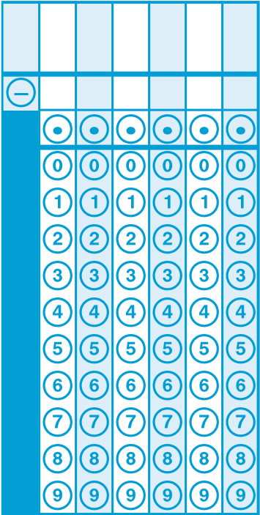

6. G.A.3
Draw polygons in the coordinate plane given coordinates for the vertices; use coordinates to find the length of a side joining points with the same first coordinate or the same second coordinate. Apply these techniques in the context of solving real-world and mathematical problems. (Conceptual Understanding & Procedural Skill and Fluency & Application)
What test questions look like:
Sample 1:
Janet is drawing a design for a rectangular deck on a coordinate plane. The length of the deck is 30 feet and the width is 10 feet. Line segment PQ, as shown below, represents the width of the deck.
10

8

6

4

2

–
2

–
4

–
6

–
8

–
10
2
4
6
8
10
–
4
–
2
y
–
6
–
8
–
10
x
Q
P
Next, she is going to draw line segment QR to represent the length of the deck.
Select all possible locations for point R.
- (–8, 5)
- (–4, 5)
- (0, 5)
- (3, 5)
- (5, 5)
- (10, 5)

6. G.A.4
Represent three-dimensional figures using nets made up of rectangles and triangles, and use the nets to find the surface area of these figures. Apply these techniques in the context of solving real-world and mathematical problems. (Conceptual Understanding & Procedural Skill and Fluency & Application)
What test questions look like:
Sample 1:
Matt folded this net to make a shape.
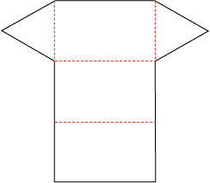
What shape did Matt make?
- 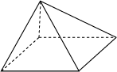
- .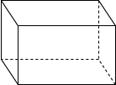
- 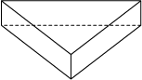
Sample 2:
The figure below is the net for a box. What is the surface area of the box?
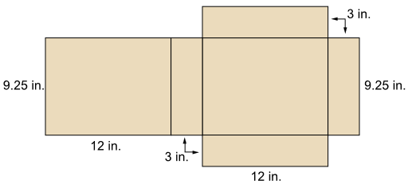

- 285.75 inches²
- .333.00 inches²
- 349.50 inches²
- 366.00 inches²

6. SP.A.1
Recognize a statistical question as one that anticipates variability in the data related to the question and accounts for it in the answers. For example, "How old am I?" is not a statistical question, but "How old are the students in my school?" is a statistical question because one anticipates variability in students' ages. (Conceptual Understanding)

What test questions look like:
Sample 1:

Which questions are statistical questions?
Select each correct answer.
- How old is Mr. Patterson?
- How many states has Juanita visited?
- How many students are in Mrs. Lee’s class today?
- How many students eat lunch in the cafeteria each day?
- How many pets does each student at your school have at home?

6. SP.A.2
Understand that a set of data collected to answer a statistical question has a distribution which can be described by its center, spread, and overall shape. (Conceptual Understanding)

What test questions look like:
Sample 1:
Use the data in the line plot to answer the question.
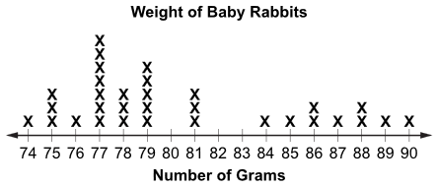
The line plot shows the weight of baby rabbits at a petting zoo.
Which statement best describes the data in this line plot?
- The data is skewed to the left.
- The data is skewed to the right.
- The data is centered at 77.
- The data is centered at 82.

Sample 2:
Which of the following statements could be made about the following line plot?
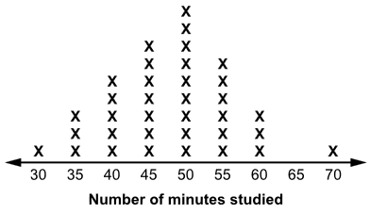

- The distribution of data is centered at approximately 48.
- The distribution of data is skewed right.
- The mode of this data distribution is 70.
- The data distribution has a cluster around values 60-70.

6. SP.A.3
Recognize that a measure of center for a numerical data set summarizes all of its values with a single number, while a measure of variation describes how its values vary with a single number. (Conceptual Understanding)

What test questions look like:
Sample 1:
Riley took 5 tests in science.
    - Each test had a different score.
    - The mean score on the tests was 90%.
    - The median score on the tests was 85%.
Based on this information, select all the statements that must be true.
- More than half of the scores were 85% or greater.
- More than half of the scores were 90% or greater.
- There were no scores less than 85%.
- There were no scores less than 90%.
- At least one score was exactly 85%.
- At least one score was exactly 90%.

6. SP.B.4
Display numerical data in plots on a number line, including dot plots, histograms, and box plots. (Procedural Skill and Fluency)

What test questions look like:
Sample 1:
Use this data to answer the question.
9, 12, 12, 11, 13, 14, 14, 11, 15
The data shows the height, in centimeters, of each seedling that Vincent planted.
Which box plot correctly displays this data?

- 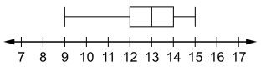

- 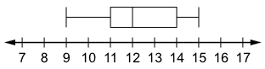

- 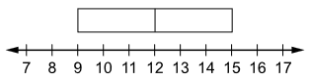

- 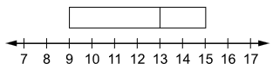

Sample 2:
Sol asked each family on his block how many pets they own. This list gives the results.
1, 3, 2, 0, 4, 1, 12, 0, 7, 2
Which box-and-whisker plot correctly displays this data?

- 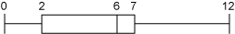

6. SP.B.5
Summarize numerical data sets in relation to their context, such as by: (Conceptual Understanding & Application)

What test questions look like:
Sample 1:
Lawrence’s recent math test scores are shown below.
75, 93, 75, 95, 82
Lawrence wants his parents to think he is doing well in the class. Which measure of central tendency, mean, median, or mode, would result in the highest score? Justify your response by comparing all three measures.

Sample 2:
This table shows the number of animals that are on the endangered species list.

Endangered and
Threatened Animals
Group | Species
Mammals | 61
Birds | 74
Reptiles | 14
Fish | 69

Which is the best explanation for why the mean should not be used to represent this data set?

- There is an outlier in the data.
- The range of the data is too large.
- There are an even number of values.
- The data do not have any recurring values.

6. SP.B.5a
Reporting the number of observations. (Conceptual Understanding & Application)

What test questions look like:
Sample 1:
NONE Available

6. SP.B.5b
Describing the nature of the attribute under investigation, including how it was measured and its units of measurement. (Conceptual Understanding)

What test questions look like:
Sample 1:
Mitch wants to determine how many motorists pass his business between the hours of 5:00 pm and 6:00 pm. How could Mitch measure this situation, and what unit of measurement should he use?

- Mitch can calculate the amount of time it takes each vehicle to pass his house between 5:00 pm and 6:00 pm. He can use "minutes" as the unit of measurement.

- Mitch can contact the Department of Motor Vehicles to identify the number of vehicles on the road between 5:00 pm and 6:00 pm. He can use "cars" as the unit of measurement.

- Mitch can issue a survey to the town and ask how many people pass his business during the hour between 5:00 pm and 6:00 pm. He can use "people" as the unit of measurement.

- Mitch can count the number of vehicles that pass his business between 5:00 pm and 6:00 pm. He can use "vehicles" as the unit of measurement.

6. SP.B.5c
Giving quantitative measures of center (median and/or mean) and variability (interquartile range and/or mean absolute deviation), as well as describing any overall pattern and any striking deviations from the overall pattern with reference to the context in which the data were gathered. (Conceptual Understanding & Procedural Skill and Fluency & Application)

What test questions look like:
Sample 1:
Tanya records the number of bicycles parked outside her school when she arrives each day for 20 school days. She makes the box plot shown below to display her data.
Bicycles at Tanya’s School

0 1 2 3 4 5 6 7 8 9 10
Between which 2 numbers do exactly 50% of Tanya’s data points lie?
- 1 and 3.5
- 3.5 and 6.5
- 3.5 and 9
- 5 and 6.5

Sample 2:
Use the information provided to answer Part A and Part B.

Data Set
21 30 39 43 58 67

Part A
The data set shows the number of minutes Julio practiced his trumpet on each of 6 days during a week. What is the mean number of minutes Julio practiced over these 6 days?
Enter your answer in the box.
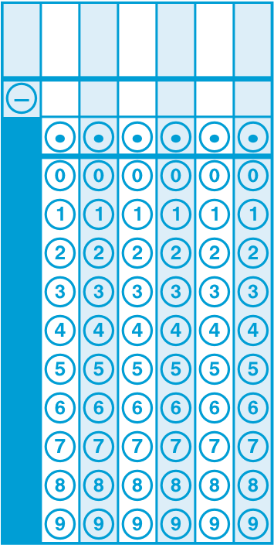

Part B
Julio practiced a 7th day during the week. The mean number of minutes he practiced over all 7 days was 45 minutes. How many minutes did Julio practice on the 7th day?
Enter your answer in the box.

6. SP.B.5d
Relating the choice of measures of center and variability to the shape of the data distribution and the context in which the data were gathered. (Conceptual Understanding & Application)

What test questions look like:
Sample 1:
For which set of data would the mean and median most likely be very different?
- ages of all the students in an elementary school

- ages of all the students in a seventh-grade class

- salaries of all employees in a small company where the president makes $500,000 per year

- salaries of all employees in a large company where the president makes $500,000 per year

6th Grade
Sample Math Items Aligned to CCSS
KEY
CCSS Code | Sample 1 | Sample 2 | Sample 3 | Sample 4
6.RP.A.1 | B | D
6.RP.A.2 | D, E | A
6.RP.A.3 | C | B
6.RP.A.3a | Part A: D  Part B: D
6.RP.A.3b | 3.75
6.RP.A.3c | 1200
6.RP.A.3d | D | D
6.NS.A.1 | 8 | See Rubric #30
6.NS.B.2 | D | C
6.NS.B.3 | See Rubric#27
6.NS.B.4 | B
6.NS.C.5 | 9 | B
6.NS.C.6 | D | D
6.NS.C.6a | See Rubric #32
6.NS.C.6b | D, F
6.NS.C.6c | D
6.NS.C.7 | C | D
6.NS.C.7a | B
6.NS.C.7b | B
6.NS.C.7c | See Rubric #32
6.NS.C.7d | NONE Available
6.NS.C.8 | 6
6.EE.A.1 | D
6.EE.A.2 | C | 28
6.EE.A.2a | See Rubric #31
6.EE.A.2b | NONE Available
6.EE.A.2c | 77 | 11
6.EE.A.3 | See Rubric #37
6.EE.A.4 | B, E | B, D
6.EE.B.5 | B
6.EE.B.6 | D
CCSS Code | Sample 1 | Sample 2 | Sample 3 | Sample 4
6.EE.B.7 | 29 | Part A: C  PartB: 1.60*
6.EE.B.8 | C
6.EE.C.9 | Part A: C  Part B: 7
6.G.A.1 | See Rubric #27
6.G.A.2 | B, E
6.G.A.3 | A, F
6.G.A.4 | B | C
6.SP.A.1 | D, E
6.SP.A.2 | A | A
6.SP.A.3 | A, E
6.SP.B.4 | B | A
6.SP.B.5 | See Rubric | A
6.SP.B.5a | NONE Available
6.SP.B.5b | D
6.SP.B.5c | B | Part A: 43  Bart B: 57
6.SP.B.5d | C
*Scorer should follow student work from part A to part B. Part B can receive credit if an incorrect response in part A is used correctly in part B.

 | 6.NS.A.1 Sample 2 (Rubric #30)
 | Score |  | Description
 | 4 |  | Student response includes each of the following 4 elements.  x Reasoning component = 3 points  - Correct explanation of how to find the number of sheets in a stack using the ruler  - Correct expression or equation that can be used to find the  number of sheets, 2 ¹ y ³ or equivalent  4 16  - Correct explanation of how expression relates to use of the ruler  x Computation component = 1 point  o Correct number of sheets of cardboard in a stack, 12  Sample Student Response:  To find the number of sheets in a stack using the ruler, you start at 2 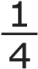inches on the ruler. Then you can mark off groups of 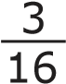. This is 3 of  the 16ths marks on the ruler. Then you can count the number of groups. There were 12 groups, so there are 12 sheets in a stack.  An expression that represents this is 2 ¹ y ³ . This relates to using  4 16  the ruler because you are starting with 2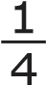 and dividing by 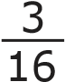, which is really finding how many groups of 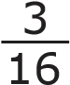 there are in 2 . When you divide, you will get 12, which means there are 12 groups of 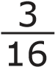 in 2 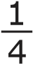.
 | 3 |  | Student response includes 3 of the 4 elements.
 | 2 |  | Student response includes 2 of the 3 elements.
 | 1 |  | Student response includes 1 of the 2 elements.
 | 0 |  | Student response is incorrect or irrelevant.
6.NS.B.3 & 6.G.A.1 Sample 1(Rubric #27)

Score |  | Description
3 |  | Student response includes the following 3 elements. x Modeling component = 2 points  - The student models a strategy for developing a reasoned estimate for an appropriate length and width of each cereal bar, including explaining assumptions.  - The student models a strategy for determining the amount each cereal bar will cost Megan to make.  x Computation component = 1 point o The student provides the amount each cereal bar will cost.  Sample Student Response:  I assume that each bar could be 2 inches by 4 inches. This is a reasonable size for a cereal bar and is easy enough to hold and does not appear to be too large a serving size. The cereal bar can also be cut so that all cereal bars are the same size and shape since 24 inches and 16 inches can be evenly divided by 2 inches and 4 inches.  For the 1 pan of bars cut so each bar is 2 inches by 4 inches, there would be 6 rows of bars (24 ÷ 4) and 8 bars in each row (16 ÷ 2). Altogether, that would make 48 bars for each pan. The amount spent on ingredients is $9.85, so the amount each cereal bar will cost Megan to make is $9.85 ÷ 48, which is $0.205… or about $0.21.  Notes: o Other reasoned estimates are possible. As long as the modeling steps are valid, credit should be awarded. o The student may receive a combined total of 2 points if the modeling processes are correct but the student makes one or more computational errors resulting in incorrect answers. o The student may receive a total of 1 point if he/she computes the correct answer but shows no work or insufficient work to indicate a correct modeling process.
2 |  | Student response includes 2 of the 3 elements.
1 |  | Student response includes 1 of the 3 elements.
0 |  | Student response is incorrect or irrelevant.

6.NS.C.6a & 6.NS.C.7c (Rubric #32)
Part A
Score | Description
2 | Student response includes each of the following 2 elements.  x Reasoning component = 1 point  o Correct work shown or explanation given using the number line  x Computation component = 1 point o Correct distance of each point from Q (0.3 for R and 0.6 for P)  Sample Student Response:  Point R is 0.3 unit from point Q, because there are 3 spaces of 0.1 between them on the number line.  Point P is 0.6 unit from point Q, because there are 6 spaces of 0.1 between them on the number line.
1 | Student response includes 1 of the 2 elements.
0 | Student response is incorrect or irrelevant.
Part B
Score | Description
1 | Student response includes the following element.  x Reasoning component = 1 point  o Correct explanation of how to find point S on the number line  Sample Student Response:  Since point Q is at 0 and since point S is the same distance from point Q as point R but in a different location, it must be on the opposite side of point Q. Points R and S are on opposite sides of 0 on the number line, so their locations should have opposite signs. Since point R is located at 0.3, point S must be located at -0.3.  Note: Point S can also be located at 0.3 for credit with a valid explanation.

6.EE.A.2a Sample 1 (Rubric #31)
#31 Part A
Score | Description
1 | Student response includes the following element. x Modeling component = 1 point  o Correct expression that represents the total amount of money raised  Sample Student Response:  15x  Note: Any valid equivalent expression can receive credit.
0 | Student response is incorrect or irrelevant.
(Rubric #31) Part B
Score | Description
Student response includes the following elementV. x Modeling component = 1 point
Sample Student Response:
“15 × 43 = 645, and 645 – 500 = 145” OR
“Using my expression, I multiplied 43 by $15 to get a total of $645 raised. I then subtracted $500 from $645 to get $145 for the amount that the club exceeded its goal.”
Notes:
x The student may receive a point if the modeling process is correct but the student makes one or more computational errors resulting in incorrect answers.
x The student may receive a point if he or she computes the correct answers but shows no work or insufficient work to indicate a correct modeling process.
If a student writes an incorrect model and answers the remaining prompts based on the model, he or she can receive 1 point for computation but no points for modeling.
1 | Student response includes 1 of the 2 elements.
0 | Student response is incorrect or irrelevant.

6.EE.B.6 (Rubric #37)
Description
Student response includes the following 3 elements:
- Explanation of why Brianna’s thinking is incorrect
- Explanation of how to determine which expressions are equivalent
- Identifies expressions A and C as equivalent Sample Student Response:
Brianna only checked the value of each expression for one substitution of x. To check which expressions are equivalent, I need to check that they are the same value for any substitution of x. 6x  4,
Since expressions A and C are both equivalent to the expression 6x – 4, they will be equivalent for any substitution of x, so they are equivalent.
Student response includes 2 of the 3 elements.
Student response includes 1 of the 3 elements.
Student response is incorrect or irrelevant.

6.SP.B.5 (Sample 1)

Description
75, 75, 82, 93, 95
82 is the middle value, so it is the median
75 occurs the most often, so is the mode
75 + 75 + 82 + 93 + 95 = 420
420/5 = 84
84 is the mean
84 > 82 > 75
He should use the mean.

Points Assigned
- 1 point for response that the mean should be used
- 1 point for finding the mean
- 1 point for finding the mode
- 1 point for finding the median

Scoring
Score | Description
2 | 4 points
1 | 1, 2, or 3 points or minimal understanding of how to find mean, median, and mode
0 | The student's response is incorrect, irrelevant, too brief to evaluate, or blank.

6th Grade
Sample Math Items Aligned to CCSS
Origination of Sample Items
CCSS Code | Sample 1 | Sample 2 | Sample 3 | Sample 4
6.RP.A.1 | 2016 Leap Practice Test #3 | 2016 Leap Practice Test #19
6.RP.A.2 | 2016 Leap Practice Test #15 | 2016 Leap Practice Test #20
6.RP.A.3 | Eagle | Eagle
6.RP.A.3a | 2016 Leap Practice Test #29
6.RP.A.3b | 2016 Leap Practice Test #34
6.RP.A.3c | 2016 Leap Practice Test #33
6.RP.A.3d | Eagle | Eagle
6.NS.A.1 | 2016 Leap Practice Test #1 | 2016 Leap Practice Test #30
6.NS.B.2 | 2016 Leap Practice Test #4 | 2016 Leap Practice Test #13
6.NS.B.3 | 2016 Leap Practice Test #27
6.NS.B.4 | 2016 Leap Practice Test #8
6.NS.C.5 | 2016 Leap Practice Test #14 | 2016 Leap Practice Test #18
6.NS.C.6 | Eagle | Eagle
6.NS.C.6a | 2016 Leap Practice Test #32
6.NS.C.6b | 2016 Leap Practice Test #7
6.NS.C.6c | 2016 Leap Practice Test #16
6.NS.C.7 | Eagle | Eagle
6.NS.C.7a | 2016 Leap Practice Test #5
6.NS.C.7b | 2016 Leap Practice Test #12
6.NS.C.7c | 2016 Leap Practice Test #32
6.NS.C.7d | NONE Available
6.NS.C.8 | 2016 Leap Practice Test #17
6.EE.A.1 | 2016 Leap Practice Test #26
6.EE.A.2 | Eagle | Eagle
CCSS Code | Sample 1 | Sample 2 | Sample 3 | Sample 4
6.EE.A.2a | 2016 Leap Practice Test #31
6.EE.A.2b | NONE Available
6.EE.A.2c | 2016 Leap Practice Test #35 | 2016 Leap Practice Test #39
6.EE.A.3 | 2016 Leap Practice Test #37
6.EE.A.4 | 2016 Leap Practice Test #2 | 2016 Leap Practice Test #25
6.EE.B.5 | 2016 Leap Practice Test #42
6.EE.B.6 | 2016 Leap Practice Test #21
6.EE.B.7 | 2016 Leap Practice Test #24 | 2016 Leap Practice Test #38
6.EE.B.8 | 2016 Leap Practice Test #10
6.EE.C.9 | 2016 Leap Practice Test #28 | 2016 Leap Practice Test #36
6.G.A.1 | 2016 Leap Practice Test #27
6.G.A.2 | 2016 Leap Practice Test #6
6.G.A.3 | 2016 Leap Practice Test #23
6.G.A.4 | Eagle | Eagle
6.SP.A.1 | 2016 Leap Practice Test #9
6.SP.A.2 | Eagle | Eagle
6.SP.A.3 | 2016 Leap Practice Test #11
6.SP.B.4 | Eagle | Eagle
6.SP.B.5 | Eagle | Eagle
6.SP.B.5a | NONE Available
6.SP.B.5b | Eagle
6.SP.B.5c | 2016 Leap Practice Test #22 | 2016 Leap Practice Test #40
6.SP.B.5d | Eagle

